GrievanceHub — Online Complaint Registration and Management System

INTRODUCTION:
GrievanceHub is a web-based complaint registration and management platform designed to make the submission, assignment, tracking, and resolution of complaints more organized and transparent. It provides a shared workspace for citizens or students, support agents, and administrators, replacing scattered follow-ups with a traceable digital complaint lifecycle.
The application is built with the MERN stack: React.js provides the client interface, Node.js and Express.js implement the API and business rules, and MongoDB stores application records through Mongoose models. Socket.IO supports complaint-related real-time communication and event notifications. The system also includes role-based access control, complaint history, category management, feedback, and administrative audit logs.
The main goal is to help users submit a complaint once, receive a reference number, follow progress, and communicate with the assigned agent. For operational staff, it provides controlled assignment, status updates, workload views, and records of important actions.

SCENARIO-BASED CASE STUDY:

Background
In an organization, complaints about facilities, services, accounts, or technical problems may arrive through calls, messages, paper forms, or informal conversations. When records are fragmented, a complainant may not know who is handling the issue, an agent may lose context, and administrators may find it difficult to measure outstanding work.

Illustrative User Scenario
A citizen notices a facility problem and opens GrievanceHub from a laptop or phone. After signing in, the citizen submits the complaint with a category, description, priority, and relevant location details. The system stores the complaint and displays a reference number. An administrator assigns it to a support agent, who records progress and communicates with the citizen. When work is complete, the agent records a resolution; the citizen can review the timeline, provide feedback, or reopen the complaint if the issue remains unresolved.

The Challenge and Proposed Solution
- Keep complaint submission simple and provide a clear reference for follow-up.
- Show status and history so users can understand progress without repeated manual enquiries.
- Give agents a focused queue of assigned complaints and authorized status controls.
- Give administrators assignment tools, workload summaries, category controls, and audit history.

SYSTEM REQUIREMENTS — SOFTWARE REQUIREMENTS

Software and development tools identified in the supplied project audit report.

The following software supports development, local execution, testing, and maintenance of GrievanceHub. Actual package versions can be checked in the project package manifests and lockfiles.

Software / Tool | Version or Configuration | Purpose
Operating System | Windows 11 x64 (reported audit environment) | Development, local services, browser testing, and command-line execution.
Node.js | v24.19.0 reported | JavaScript runtime for the Express API and development scripts.
npm | v11.17.0 reported | Dependency installation and package scripts.
React.js + Vite | React 18.3.1; Vite 6.x | Frontend single-page application and development/production build.
React Router DOM | 6.28.2 reported | Client-side navigation and route guards.
Axios | 1.7.9 reported | HTTP client for REST API requests and request configuration.
Bootstrap / Icons | Bootstrap 5.3.3; Bootstrap Icons 1.11.3 | Responsive layout, controls, and interface iconography.
Node.js + Express.js | Express 4.21.2 reported | Backend HTTP server, route handling, and application middleware.
MongoDB + Mongoose | MongoDB 7.x/8.x compatible; Mongoose 8.9.5 reported | Document database, schema validation, references, and data persistence.
JWT + bcryptjs | jsonwebtoken 9.0.2; bcryptjs 2.4.3 | Signed session tokens and password hashing.
Socket.IO | 4.8.1 reported | Real-time complaint messages and event notifications.
Multer | 1.4.5-lts.1 reported | Multipart evidence uploads with file restrictions.
Security / logging | Helmet 8.0.0; express-rate-limit 7.5.0; Morgan 1.10.0 | Security headers, request throttling, and HTTP request logs.
Browser / editor | Chrome or Firefox; Visual Studio Code or equivalent | UI verification, inspection, and source editing.
Testing tools | Puppeteer-Core 24.x; custom Node.js test scripts | Browser automation, API tests, regression probes, and screenshot capture.

Note: Some audit notes describe Vite as 6.1.0 while the build report identifies a Vite 6.x build. The report therefore states the major version family; the installed exact version should be treated as the package-lock source of truth.

SYSTEM REQUIREMENTS — HARDWARE AND FUNCTIONAL SCOPE

- Hardware Requirements

Component | Minimum Practical Requirement | Recommended for Development
Processor | Modern dual-core CPU | Intel Core i5 / AMD Ryzen 5 or equivalent
Memory (RAM) | 8 GB | 16 GB or more when running editor, browser, and two servers together
Storage | At least 3 GB free for dependencies and project files | 5–10 GB free for dependencies, build output, screenshots, and local database files
Display | 1366 × 768 pixels | 1920 × 1080 or larger for comfortable source and dashboard inspection
Network | Internet access for first-time package installation and optional cloud services | Stable internet for MongoDB Atlas or external email services; local development can use a local database

2. Functional Requirements
- Registration and login for ordinary users; controlled creation of agent and administrator accounts.
- Complaint submission with title, description, category, priority, contact/location details, and optional evidence attachments.
- Unique complaint reference, stored status, searchable complaint lists, and status history.
- Administrator assignment/reassignment to eligible agents and account/category management.
- Agent queue, permitted status transitions, progress notes, and resolution summary.
- Complaint-specific messaging, in-app notifications, user feedback, and administrative reporting.

3. Non-Functional Requirements
- Security: password hashing, authenticated routes, role-based authorization, safe input handling, and protected complaint ownership.
- Usability: consistent navigation, visible status badges, form validation, and actionable success/error messages.
- Performance: indexed search fields, paginated lists, and asynchronous API requests.
- Reliability: centralized error handling, persisted records, and clear reporting of configuration/database issues.
- Maintainability: separated React pages, Express routes/controllers, middleware, and Mongoose models.
- Responsiveness: support desktop screens and a narrow mobile viewport.

TECHNICAL ARCHITECTURE

A decoupled three-tier MERN design with real-time event communication and file attachment handling.

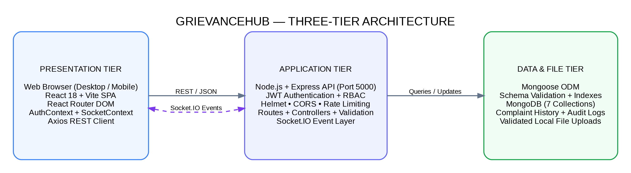
Figure 1: GrievanceHub technical architecture — presentation, application, and data tiers.

Technical Architecture Overview
The React single-page application renders the interface and calls backend APIs through Axios. Express.js receives requests, applies security and role checks, and dispatches them to route/controller logic. Mongoose validates and maps records to MongoDB collections. The Socket.IO layer supports complaint-specific communication and live events, while Multer controls the receipt of evidence files.

User Interface (UI): React pages and reusable components provide forms, dashboards, timelines, filters, and role-specific navigation.
Application/API tier: Express routes and controllers implement authentication, complaint workflows, assignment, status changes, messaging, feedback, and administration.

Security layer: JWT authentication and role-based authorization are supported by Helmet, CORS configuration, rate limiting, validation, and centralized error handling.

Data and files: Mongoose models persist users, complaints, messages, notifications, categories, feedback, and audit logs. Uploaded evidence is handled through the configured upload storage.

Real-time communication: Socket.IO supports complaint-room messages and notification/status events; REST APIs remain responsible for standard request/response operations.

ENTITY-RELATIONSHIP DIAGRAM

The model below summarizes the principal records and their links, based on the supplied Mongoose schema audit.

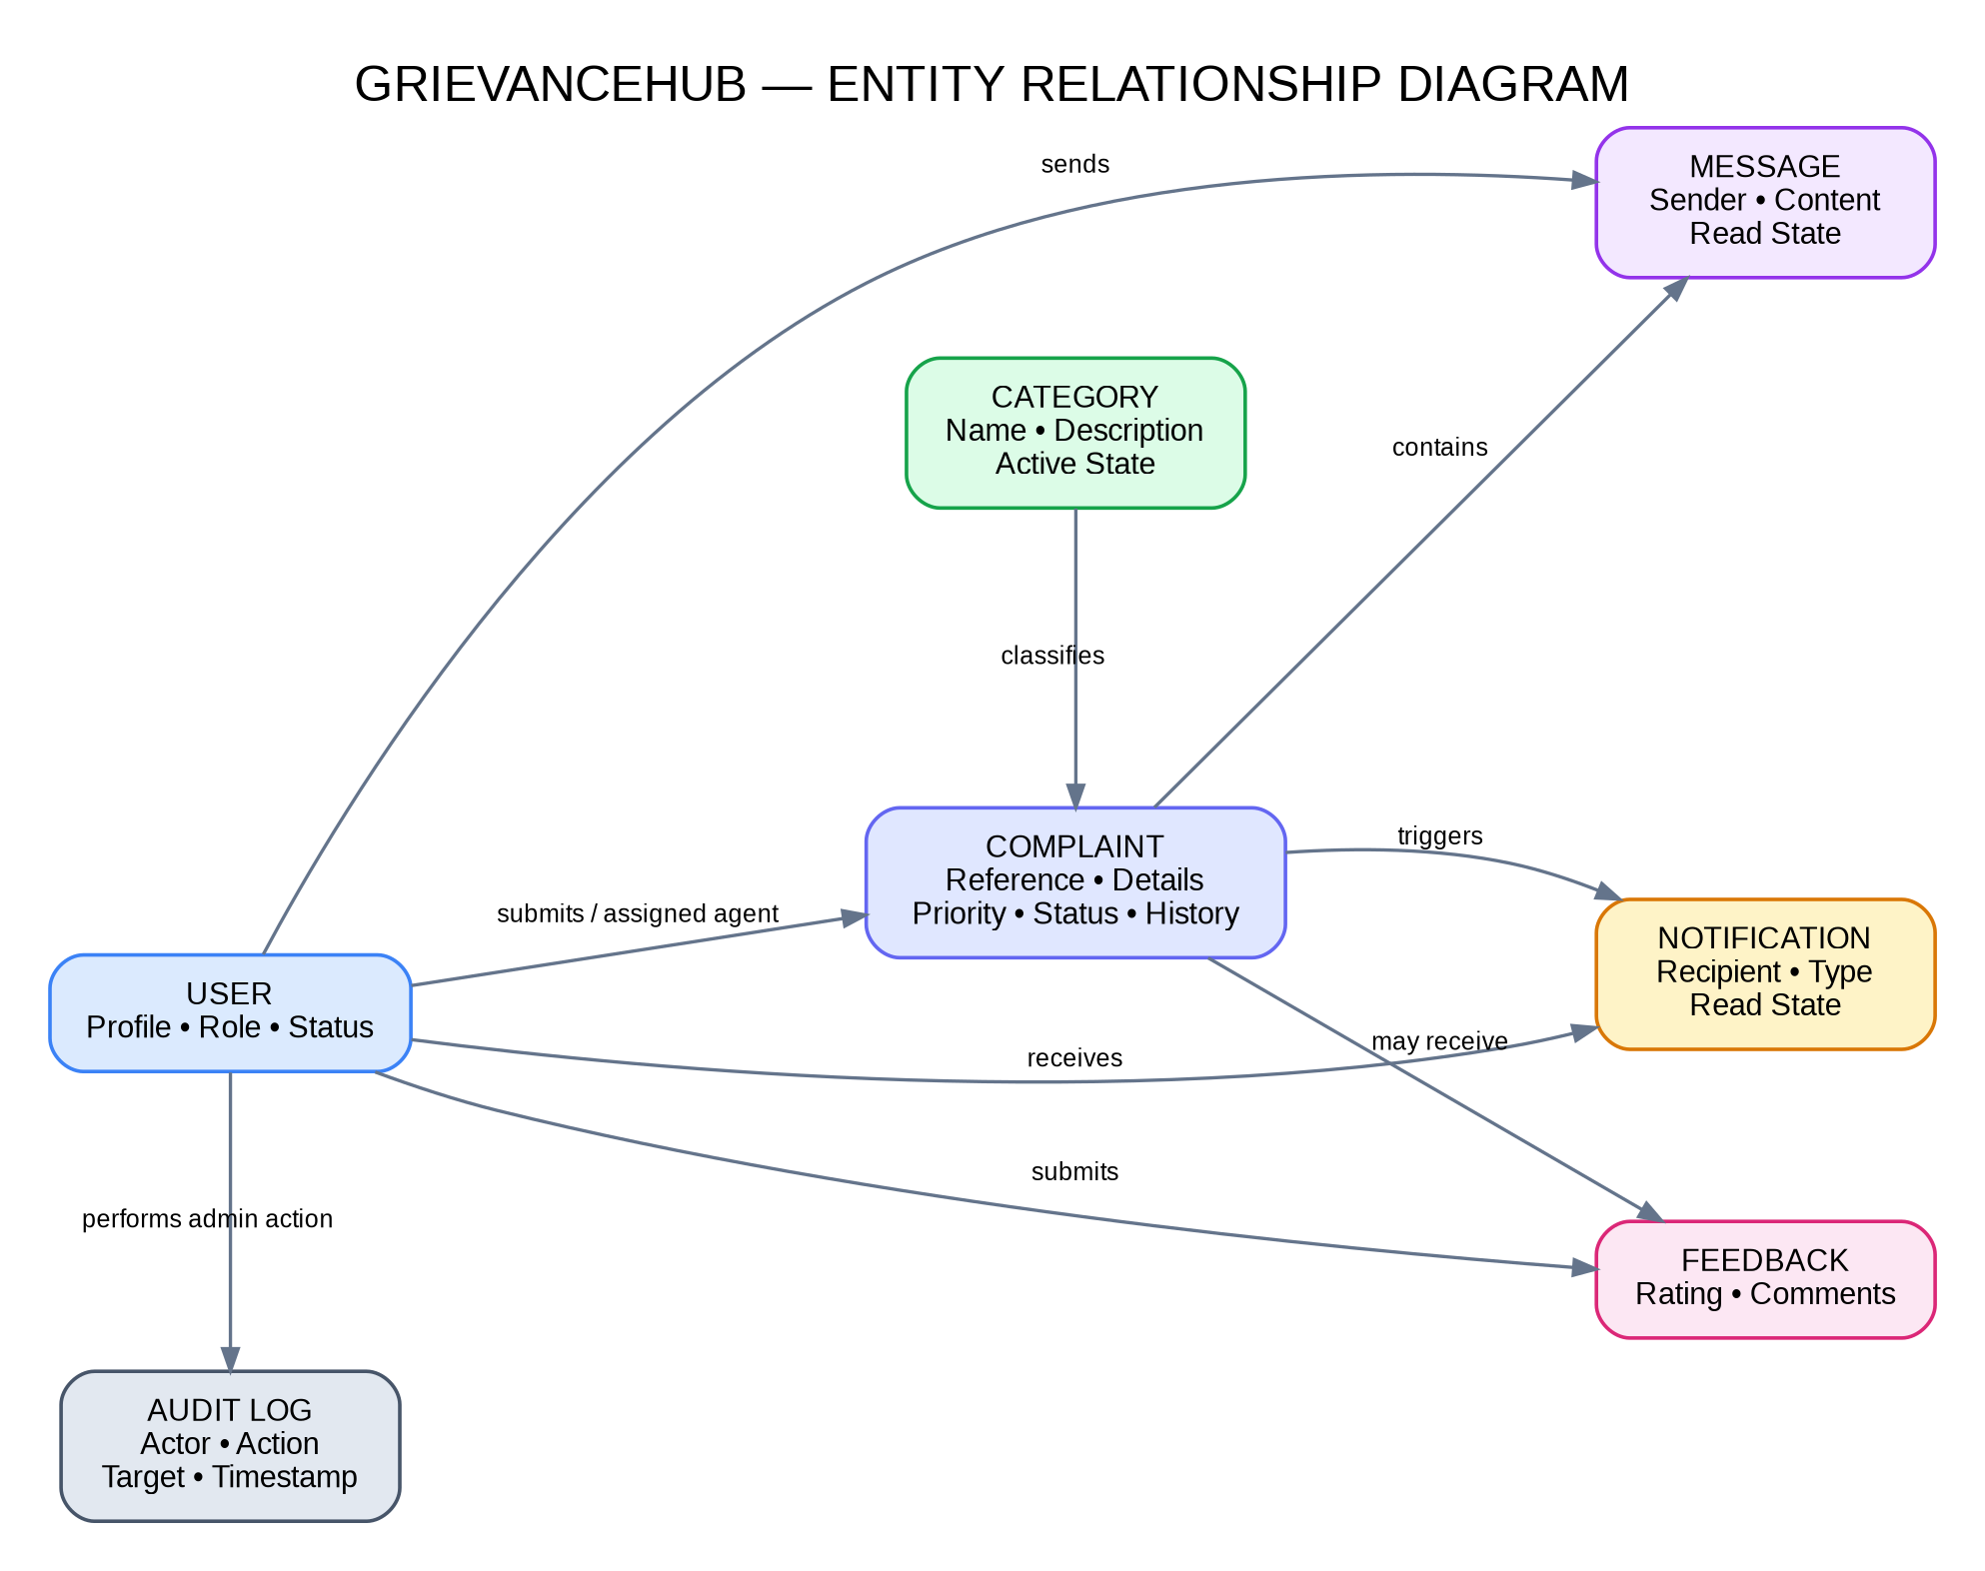
Figure 2: High-level entity relationships in GrievanceHub.

Entities and Relationships
User records represent citizens, agents, and administrators. A complaint references its creator and may reference an assigned agent. Each complaint belongs to a category and can be linked to messages, notifications, and feedback. Administrative actions are recorded in the audit log.

Relationship | Meaning
User → Complaint | A user submits complaints; a support agent may be referenced as the assigned handler.
Category → Complaint | The category classifies each complaint and is validated against the category collection.
Complaint → Message | A complaint can have multiple messages in its discussion thread.
Complaint → Feedback | A resolved complaint may have a single feedback record linked to its owner.
Complaint → Notification | Complaint events can trigger notifications for relevant recipients.
User → AuditLog | Administrative actions record the acting user and the target of the action.

DATABASE ENTITIES AND DATA DICTIONARY

The audit report identifies seven principal Mongoose models. The following table summarizes their purpose and selected fields; the actual schemas remain the authority for field-level validation.

Model / Collection | Purpose | Selected fields / constraints
User / users | Accounts and role authorization. | name, unique normalized email, bcrypt-hashed password, role USER/AGENT/ADMIN, status ACTIVE/INACTIVE, phone, department, timestamps.
Complaint / complaints | Main grievance record and lifecycle. | unique complaintNumber (CMP-YYYYMMDD-XXXXXX), title, description, category, priority, status, user ref, assignedAgent ref, attachments, history, resolvedAt, closedAt.
Message / messages | Complaint discussion messages. | complaint ref, sender ref, senderName, senderRole, message text, readBy, createdAt.
Notification / notifications | Recipient-facing alerts. | recipient ref, type, title, message, relatedComplaint ref, read flag, createdAt.
Category / categories | Complaint category definitions. | unique name, description, isActive flag, createdAt.
Feedback / feedbacks | Citizen satisfaction after resolution. | unique complaint ref, user ref, integer rating from 1–5, comments, createdAt.
AuditLog / auditlogs | Administrative and security action trail. | actor ref, actorName/role/email snapshot, action, targetType, targetId, IP/user-agent metadata, details, createdAt.

Data Integrity and Indexing
- Unique indexes are reported for normalized user email, complaint reference, category name, and feedback complaint reference.
- Complaint status, priority, user reference, assigned-agent reference, and frequently queried fields use indexes where defined.
- Mongoose validation constrains roles, status values, required fields, and allowed rating values.
- Password values are stored as bcrypt hashes and excluded from ordinary query/API responses where configured.
- References and ownership checks ensure that complaint details and conversations are visible only to authorized participants.

KEY FEATURES

GrievanceHub combines citizen-facing complaint handling with agent operations and administrative oversight. The major implemented feature areas reported in the project audit are summarized below.

Feature Group | Main Capabilities | Value to the User / Organization
User Management | Registration, login, profile updates, password changes, role restrictions. | Provides an identifiable account and role-appropriate access.
Complaint Registration | Title, description, category, priority, location/contact fields, optional attachments. | Captures the problem in a consistent, searchable record.
Reference and Tracking | Unique CMP reference, complaint list, detailed timeline, history and current status. | Makes progress and prior actions easier to follow.
Assignment Workflow | Admin assigns or reassigns active complaints to available support agents. | Creates clear ownership of complaint handling.
Agent Operations | Assigned queue, progress notes, status changes, resolution summary. | Supports structured handling and resolution.
Communication | Complaint-specific messages with Socket.IO event delivery and stored thread history. | Allows authorized participants to exchange details without losing context.
Notifications | In-app alerts for assignment, status changes, messages, and feedback events. | Helps users and agents notice important workflow changes.
Feedback and Reports | 1–5 integer-star rating, comments, administrative feedback table and analytics. | Captures service satisfaction and supports review.
Governance and Audit | Administrator audit log, status/assignment history, category controls. | Improves traceability of important system actions.
Responsive Layout | Desktop and mobile responsive views, role-specific navigation, status badges. | Provides access from common screen sizes.

Complaint Status Values
The reported lifecycle includes Submitted, Pending, Assigned, In Progress, Resolved, Reopened, and Closed. Available actions depend on role and current status; closed complaints are treated as archived for messaging and assignment operations.

ROLES AND RESPONSIBILITIES

1. Ordinary User / Citizen
The ordinary user initiates the complaint process and follows the issue until resolution.
- Register with required details, sign in, sign out, and maintain permitted profile information.
- Submit a complaint with a category, priority, description, relevant contact/location details, and allowed evidence attachments.
- Review the personal complaint list and open complaint details using the unique reference number.
- Inspect the current status and history timeline, including assignment and progress updates.
- Exchange messages with the assigned agent through the complaint discussion thread.
- Read in-app notifications and provide a rating/comment after resolution.
- Reopen an eligible resolved complaint by providing a reason when the issue is not yet resolved.

2. Support Agent
The agent handles complaints assigned by the administrator and records progress in the system.
- Sign in and review assigned complaints and workload indicators.
- Open assigned complaint details, review the description/evidence, and communicate with the complainant.
- Move complaints through permitted status transitions and add progress notes.
- Record resolution notes and update the status when the work is complete.
- Resume work on a complaint reopened by the citizen, where permitted by the workflow.

3. Administrator
The administrator manages platform operations and monitors complaint handling.
- Review the dashboard and master complaint register, search/filter records, and monitor status distribution.
- Assign or reassign complaints to active agents and review current workloads.
- Manage eligible user and staff accounts, including account status and role/department where authorized.
- Create or deactivate complaint categories and review citizen feedback.
- Review audit logs and important administrative actions.

USER FLOW AND COMPLAINT LIFECYCLE

The citizen workflow begins with account access and ends with feedback or a controlled reopen action. Assignment and resolution actions are performed by the authorized staff roles.

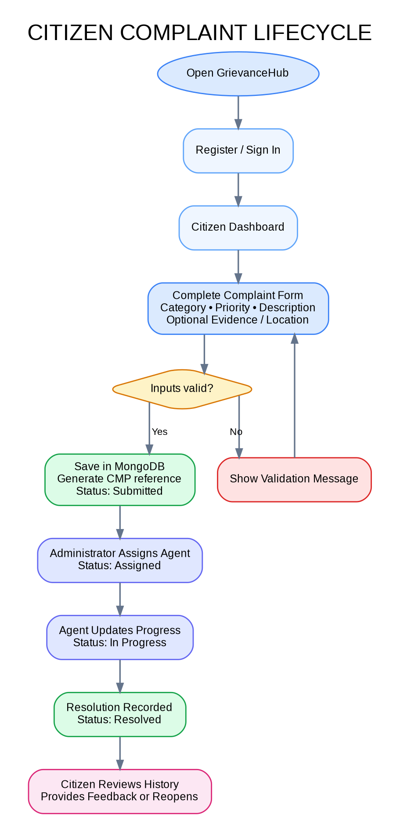  Figure 3: Citizen complaint lifecycle | 1. Visit and authenticate  The user opens the portal and registers or signs in.  2. Submit the complaint  The user enters required details and selects a valid active category.  3. Store and reference  The API validates the request, persists the record, creates a complaint reference, and records its initial status.  4. Assign and work  The administrator selects an eligible agent; the agent reviews, communicates, and updates progress.  5. Resolve and notify  The agent records the resolution summary and the system updates complaint history and relevant notifications.  6. Feedback or reopen  The citizen can rate the service after resolution or reopen an eligible case with a reason.

Lifecycle Rules
- Submitted complaints are available for administrative review and agent assignment.
- Agents may start work on Assigned complaints and resume eligible Reopened complaints.
- Resolution and reopening events should be recorded with actor and timestamp details; reopening resets the resolution timestamp.
- Closed complaints are treated as archived by the reported messaging and assignment protections.

MVC PATTERN AND APPLICATION COMPONENTS

The backend follows a layered organization that resembles MVC responsibilities: React provides the presentation layer, Express routes and middleware receive and protect requests, controllers implement application logic, and Mongoose models mediate database operations.

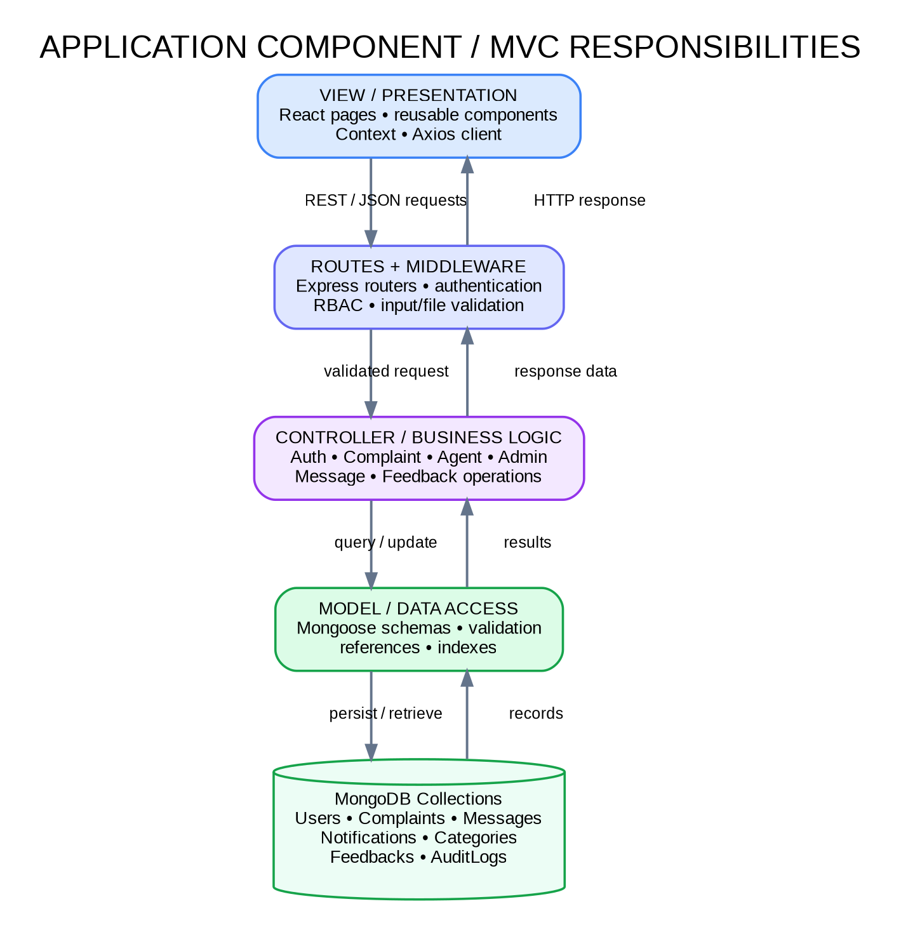  Figure 4: Application component / MVC responsibilities | View / Presentation Layer  React pages, shared components, contexts, and CSS render dashboards, forms, complaint details, filters, chat, and feedback.  Routing and Middleware  Express routers map URLs and methods. Middleware verifies identity, checks roles, validates incoming data, handles uploads, and centralizes errors.  Controller Layer  Controllers coordinate business operations such as registration, complaint creation, assignment, status transitions, messaging, feedback, and reporting.  Model / Data Layer  Mongoose schemas define field requirements, enums, indexes, references, and document validation for MongoDB.  Response and events  Controllers return JSON responses through Express. Socket.IO dispatches appropriate real-time events for messages and notifications.

Benefits of Layered Responsibilities
- Separation of concerns makes modules easier to understand and modify.
- API controllers and database models can be tested independently.
- Common authorization, validation, and error handling can be reused consistently.
- New complaint categories or workflow extensions can be added without rebuilding the entire interface.

PROJECT SETUP AND CONFIGURATION

- Project Directory

D:\Online Complaint\
├── package.json # Root scripts and workspace setup
├── client/ # React + Vite frontend
│ ├── package.json
│ └── src/
│ ├── main.jsx
│ ├── App.jsx
│ ├── context/
│ ├── components/
│ └── pages/
├── server/ # Express API and Socket.IO
│ ├── package.json
│ ├── src/
│ │ ├── server.js
│ │ ├── app.js
│ │ ├── config/
│ │ ├── models/
│ │ ├── controllers/
│ │ ├── middleware/
│ │ ├── routes/
│ │ └── utils/
│ ├── test/
│ └── data/db/ # Local embedded DB path if enabled
└── documentation_assets/ # Audit evidence and screenshots

2. Install and Configure
From the project root, install dependencies and configure the backend environment. Keep secrets in a local environment file and do not commit that file to version control.

npm run install-all
# Create/configure server/.env using local secret values
npm run seed # optional: populate demonstration data
npm run dev # start frontend and backend together

- Environment Variables

Variable | Purpose / Example
PORT | Backend port; default reported as 5000.
NODE_ENV | development or production.
MONGODB_URI | Local MongoDB URI or MongoDB Atlas connection URI.
ALLOW_MEMORY_DB_FALLBACK | Enables the configured embedded database fallback when set to true.
JWT_SECRET / JWT_EXPIRES_IN | Secret for signing tokens and configured token validity duration.
CLIENT_URL | Trusted frontend origin, reported as http://localhost:5173.
MAX_FILE_SIZE | Maximum upload size in bytes; 5242880 represents 5 MB.

BACKEND DEVELOPMENT — SERVER AND API STRUCTURE

The backend is built with Node.js and Express.js. The server entry point initializes the database connection, wraps the Express app in an HTTP server, attaches Socket.IO, and listens on the configured port. The Express application configures middleware and mounts the API routers.

Module / File | Responsibility
server/src/server.js | Bootstraps database connection, HTTP server, Socket.IO, and graceful shutdown.
server/src/app.js | Configures Helmet, CORS, cookie parsing, request logging, JSON body parsing, static upload serving, rate limiters, and API routers.
config/db.js | Connects to MongoDB through Mongoose and provides configured local/cloud or fallback behavior.
controllers/authController.js | Registration, login, logout, current-user profile retrieval, and profile updates.
controllers/complaintController.js | Complaint creation, listing, details, history, and reopening.
controllers/agentController.js | Assigned complaint list, status transitions, and progress notes.
controllers/adminController.js | Dashboard aggregation, user/staff management, assignment, categories, and audit logs.
controllers/messageController.js | Authorized complaint message retrieval and submission.
controllers/feedbackController.js | Complaint feedback submission and administrative feedback reporting.
middleware/authenticate.js | Verifies authenticated identity and active user status.
middleware/authorize.js | Enforces role-specific authorization.
middleware/upload.js | Applies upload size and MIME-type rules.
middleware/errorHandler.js | Normalizes API errors and prevents unsafe internal error exposure.

API Route Groups

Base Path | Main Operations
/api/auth | Register, login, logout, current-user profile.
/api/complaints | Create/list complaints, details, history, reopen, messages, feedback.
/api/agent | Agent dashboard, assigned queue, status updates, progress notes.
/api/admin | Admin dashboard, users/staff, agent assignment, categories, audit logs.
/api/notifications | List notifications, mark one read, or mark all read.

BACKEND DEVELOPMENT — WORKFLOW, SECURITY AND VALIDATION

Request Processing
- A client sends an HTTP request using Axios or a Socket.IO event for real-time communication.
- Express applies global security/configuration middleware such as Helmet, CORS, body parsing, request logging, and rate limiting.
- Protected endpoints validate the session, check the active account, and enforce role and complaint-ownership rules.
- Controllers validate input and execute application rules through Mongoose models.
- The API returns structured JSON success or error responses; workflow events may also create notifications or socket events.

Security Controls

Control | Implementation Purpose
JWT authentication and role checks | Protect user, agent, and administrator resources; do not rely only on frontend navigation guards.
bcryptjs hashing | Store passwords as salted hashes rather than plaintext.
Helmet, CORS, and rate limiting | Set browser security headers, limit trusted origins, and reduce abusive request rates.
Validation and query sanitization | Reject invalid fields/categories and escape regular-expression metacharacters in search inputs.
File restrictions | Multer configuration limits file size (reported as 5 MB) and accepted MIME types.
Audit trail and history | Record important administrative actions and complaint lifecycle changes with actors and timestamps.
Central error handler | Handle validation/cast failures without exposing secrets or internal stack traces in production.

Defect-Fix Evidence
The supplied QA report records seven defects as fixed and closed: unsafe regular-expression search, invalid/inactive complaint categories, messaging on closed complaints, stale resolution timestamps after reopening, assignment to closed complaints, decimal feedback ratings, and a missing agent action for reopened complaints. Retest notes state that the targeted defect probes passed.
Testing figures in the supplied materials are reported test results; this document records them from that evidence package and does not independently execute the test scripts.

DATABASE DEVELOPMENT — MONGODB AND MONGOOSE

Database Connection and Persistence
GrievanceHub uses MongoDB through Mongoose. The audit report describes support for a local MongoDB service or MongoDB Atlas, with an optional embedded database fallback configured for local development. The supplied runtime report identifies `server/data/db` as the persistent fallback data path and reports the WiredTiger storage engine.

# Example local database URI (configure in server/.env)
MONGODB_URI=mongodb://127.0.0.1:27017/OnlineComplaintRegistration
# Install dependencies from the project root
npm run install-all
# Run application and tests
npm run dev
npm test
node server/test/qa-defect-hunt.js
npm run build

Model Design Principles
- Required fields and enums constrain user roles, complaint priorities, and complaint statuses.
- Unique indexes protect user emails, complaint reference numbers, category names, and one-feedback-per-complaint behavior.
- References link complaints to users and assigned agents, and link messages, feedback, and notifications to complaint records.
- Complaint history stores status transitions, action notes, actor identity, and timestamps.
- Attachment records store metadata such as filename, path, type, size, and upload time; access must be controlled by the application.
- Dashboard values are aggregated from stored records rather than designed as fixed demo counters.

Collections at a Glance

Collection | Typical Purpose
users | Identity, role, account state, contact details.
complaints | Complaint text, priority, status, ownership, assignment, attachments, history.
messages | Complaint conversation content and sender/read state.
notifications | Recipient alerts and read/unread state.
categories | Category descriptions and active state.
feedbacks | One-to-five-star review and comments for a complaint.
auditlogs | Administrative action and security metadata.

FRONT-END DEVELOPMENT — REACT STRUCTURE AND ROUTES

The frontend is a React 18 single-page application built with Vite. Its source separates shared components, role-specific pages, authentication and socket contexts, and the Axios API client. React Router DOM handles client-side navigation and protected views.

client/src/
main.jsx # React bootstrap
App.jsx # Routes and protected route layout
api/axiosClient.js # Central HTTP client
context/AuthContext.jsx # Authentication/session state
context/SocketContext.jsx # Socket.IO lifecycle and events
components/common/ # Navbar, Footer, guards, alerts
components/complaints/ # Filter bar and complaint timeline
components/chat/ # ChatWindow
pages/public/ # Landing, Login, Register, access denied
pages/user/ # User dashboard and complaint pages
pages/agent/ # Agent queue and complaint controls
pages/admin/ # Admin dashboard and management

Important Frontend Routes

Route | Component / Purpose | Access
/ | LandingPage — overview and entry actions. | Public
/register; /login | RegisterPage / LoginPage — account access. | Public
/user/dashboard | UserDashboard — counters and recent complaints. | USER
/user/submit-complaint | SubmitComplaint — complaint registration form. | USER
/user/my-complaints | MyComplaints — personal list, filters, pagination. | USER
/complaints/:id | ComplaintDetails — details, history, chat, reopening, feedback. | Authorized participant
/agent/dashboard; /agent/complaints | AgentDashboard / AgentComplaints — queue and workload. | AGENT
/agent/complaints/:id | AgentComplaintDetails — progress notes and resolution controls. | AGENT
/admin/dashboard; /admin/complaints | AdminDashboard / AllComplaints — analytics and assignment. | ADMIN
/admin/users; /admin/categories | UserManagement / CategoryManagement. | ADMIN
/admin/feedback; /admin/audit-logs | FeedbackReports / AuditLogs. | ADMIN

Shared interface components include the responsive navigation bar, notification dropdown, complaint timeline, filter bar, status/priority badges, metric cards, loading indicator, and chat window.

IMPLEMENTATION VALIDATION, RESPONSIVE UI AND SECURITY

Testing and Build Summary
The supplied project audit reports an automated backend integration suite of 20/20 test cases passed and a targeted defect-hunt suite of 11/11 probes passed. The frontend production build is reported as successful with no compilation errors. These results are transcribed from the provided QA/audit material.

Verification Area | Reported Result
Registration, login, role restrictions | Integration tests passed for account creation, authentication, and cross-role denial.
Complaint lifecycle and assignment | Tests passed for complaint creation, administrator assignment, agent status changes, and history.
Messaging and feedback | Tests passed for permitted conversation access, message delivery, rating validation, and duplicate feedback protection.
Defect retest | 11/11 targeted probes passed for BG-001 to BG-007 behaviors.
Production build | Vite production build completed successfully; reported build transformed 1,713 modules.
External SMTP / OAuth | Live outbound SMTP requires credentials; third-party social sign-in is outside the stated capstone scope.

Security Access and Mobile Presentation
The access-denied view gives an explicit 403 response for restricted paths. The supplied mobile capture uses a 390 × 844 viewport and shows a narrower, responsive landing-page layout.

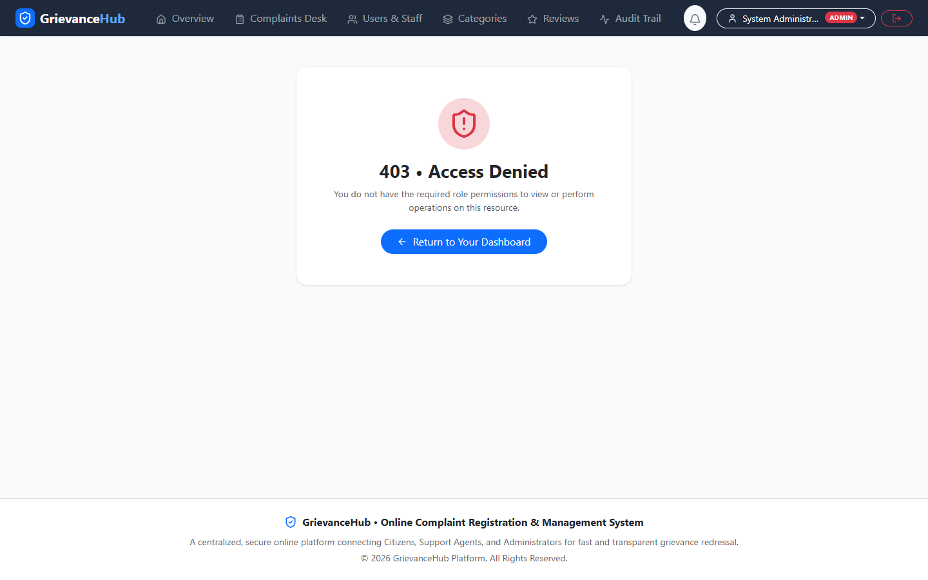  Figure 5: Role-protected access-denied page | 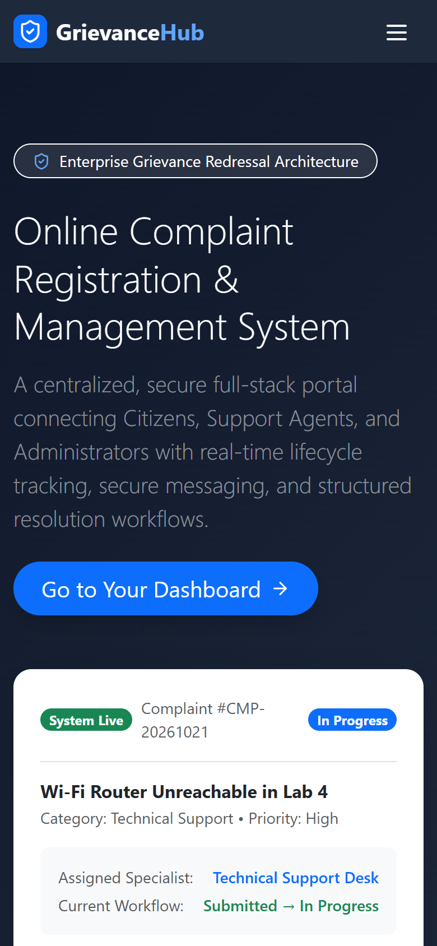  Figure 6: Mobile responsive landing page (390 × 844)

PUBLIC PAGES AND AUTHENTICATION

These screens show the entry point and the authentication path before a user can open role-specific complaint functions.

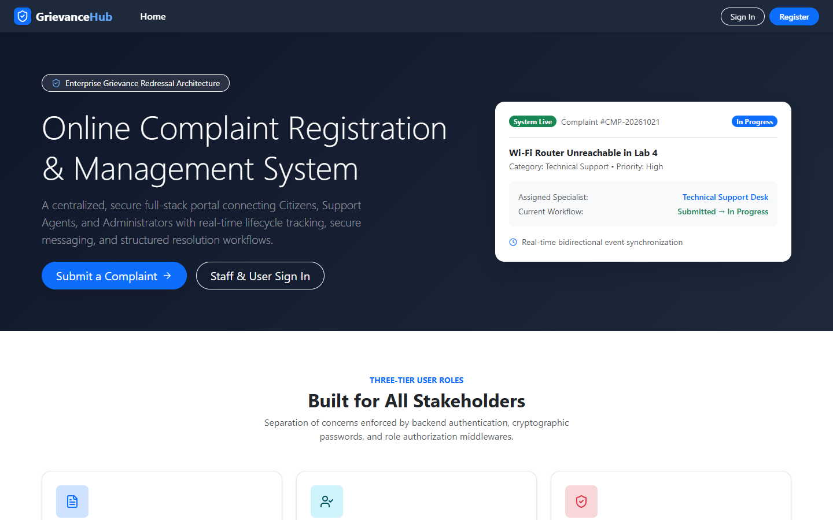  Figure 7: Landing / Home Page  Public overview, system introduction, and entry actions. | 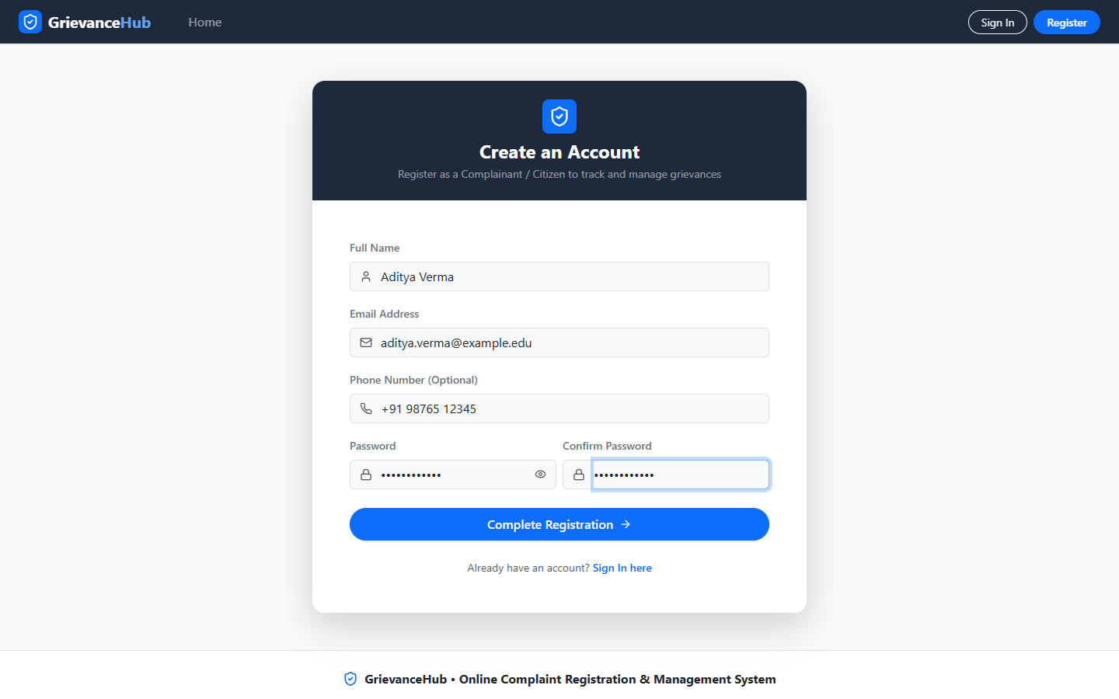  Figure 8: User Registration  New complainant registration form and validation fields.
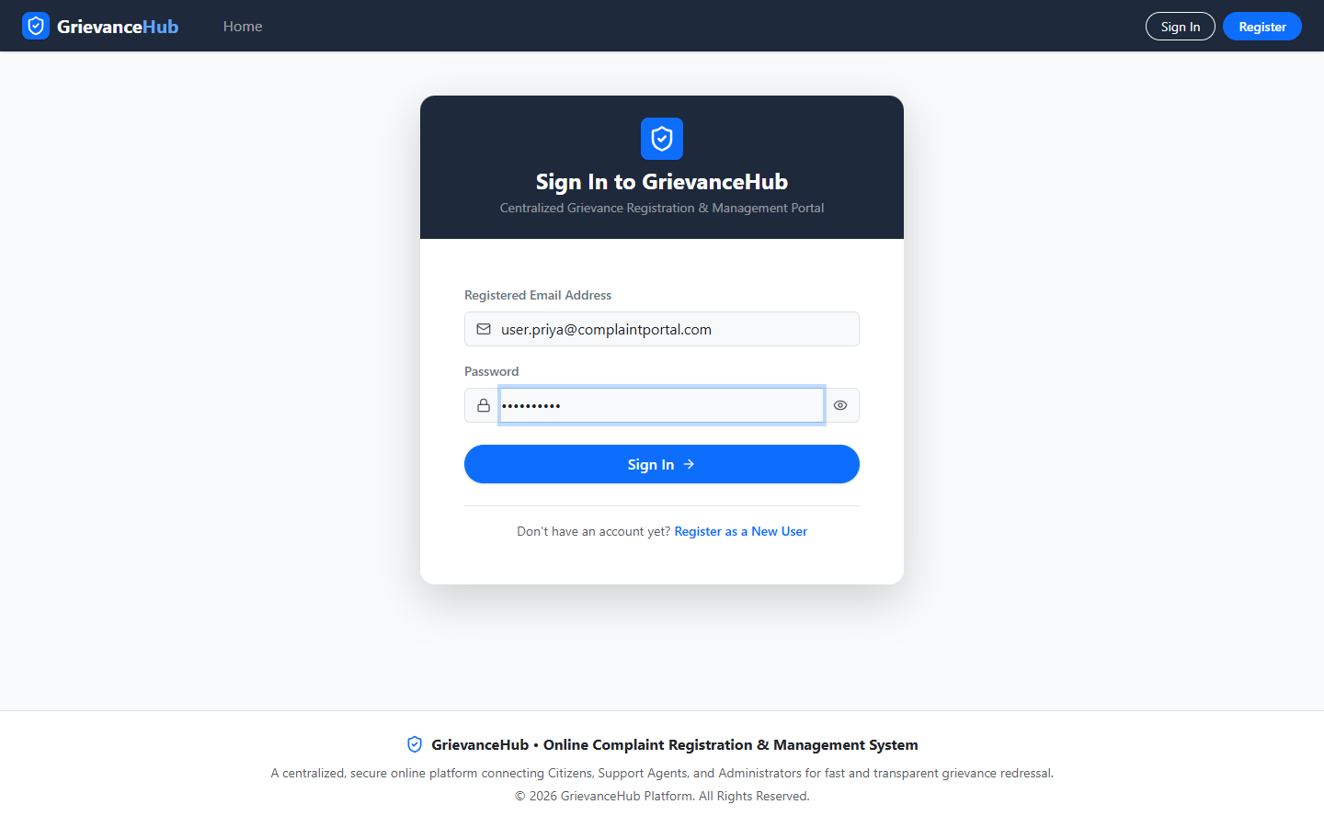
Figure 9: User Login
Credential form for authenticated access.

Interface Notes

- The landing page introduces the grievance portal and directs visitors toward complaint submission or account access.
- Registration and login are separate public routes; protected functions are reached only after authentication.

CITIZEN COMPLAINT MODULE

The citizen-facing module supports personal dashboard review, complaint filing, complaint-list filtering, and detailed status/history inspection.

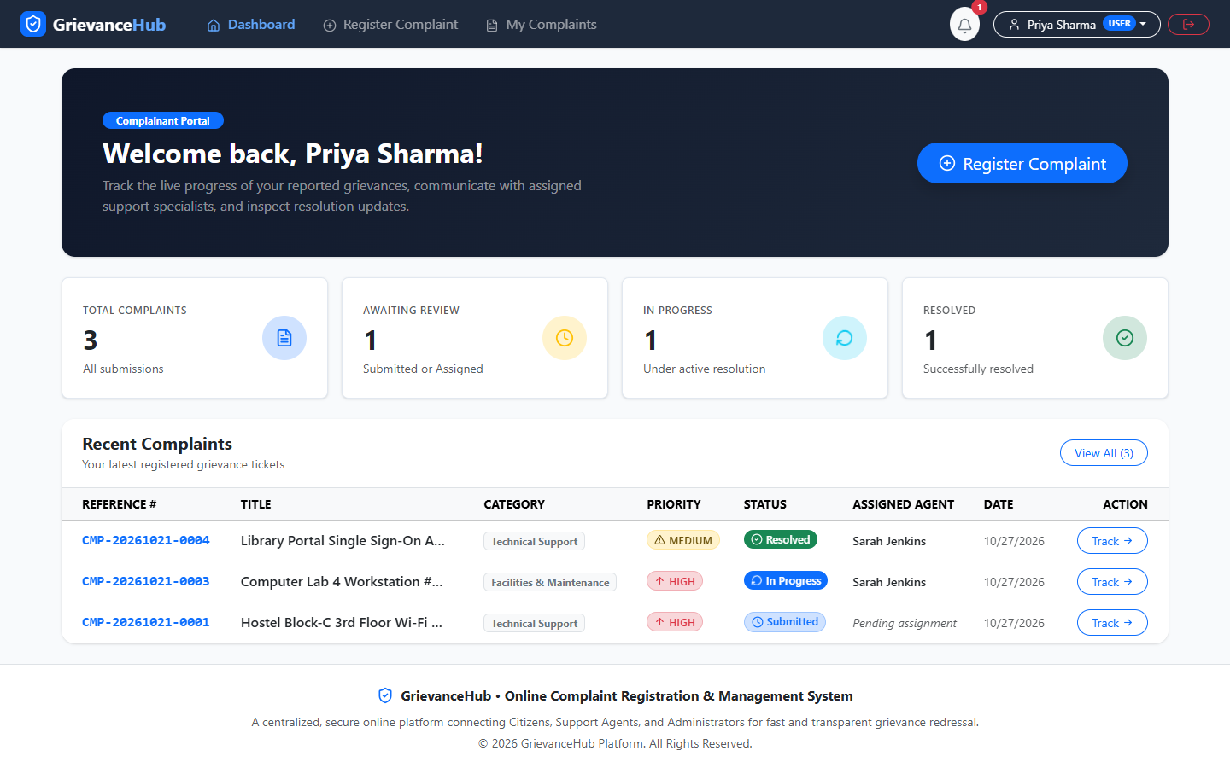  Figure 10: Citizen Dashboard  Summary KPI cards and the citizen’s recent complaint records. | 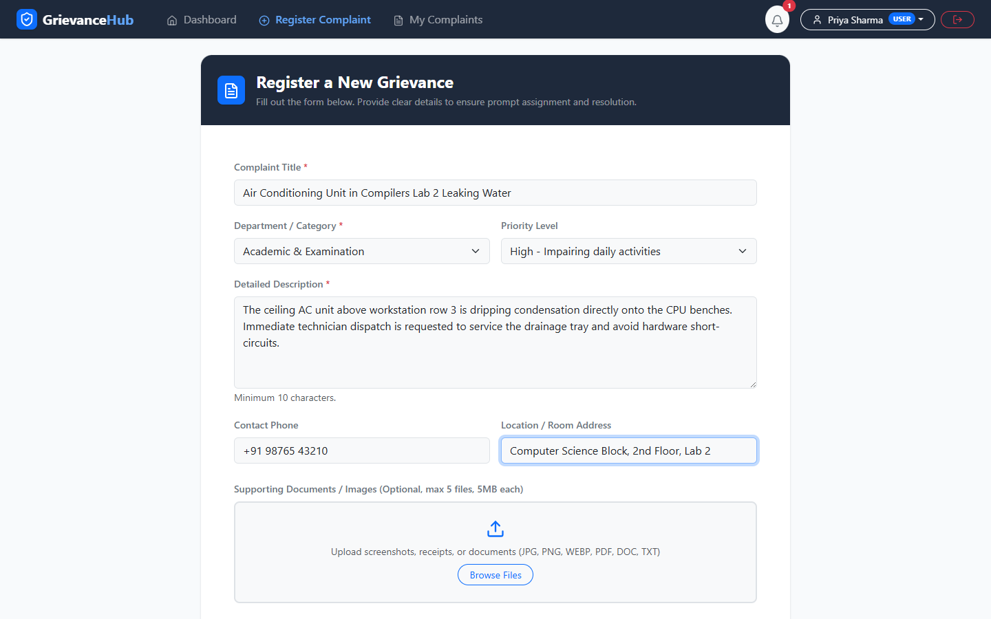  Figure 11: Complaint Submission  Form for title, category, priority, description, and location/evidence.
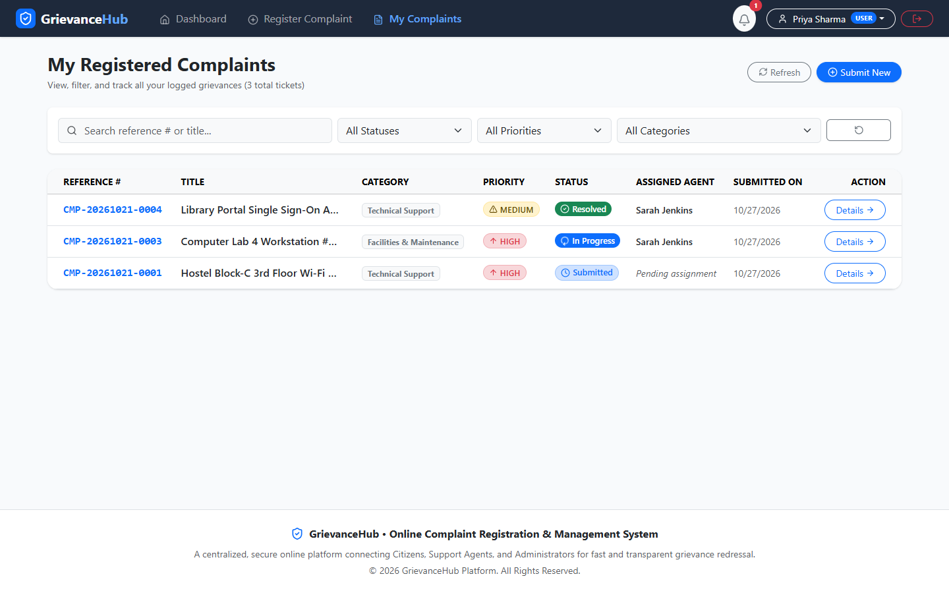  Figure 12: My Complaints  Personal grievance register with status, priority, and filters. | 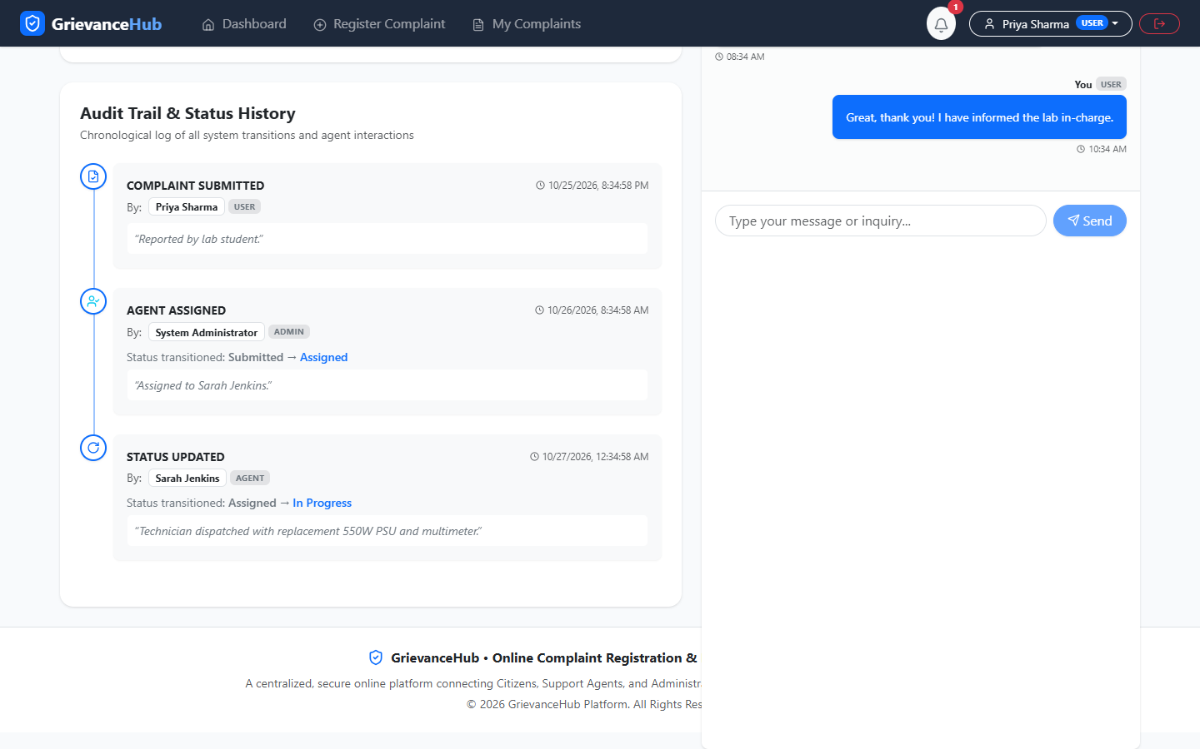  Figure 13: Complaint Details & History  Complaint detail and the lifecycle timeline.

COMMUNICATION AND SUPPORT QUEUE

Communication and notification functions keep the complaint thread connected to its registered record. The page also shows the profile and the agent’s assigned-work overview.

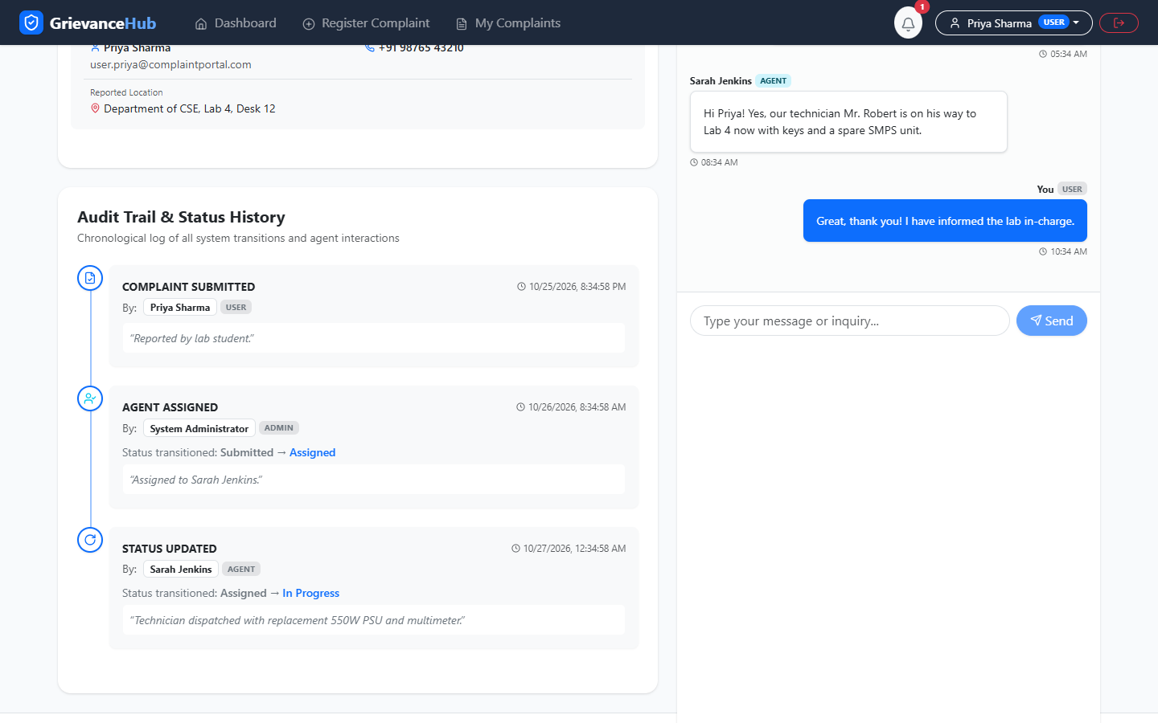  Figure 14: Complaint Messaging  Conversation thread linked to a complaint. | 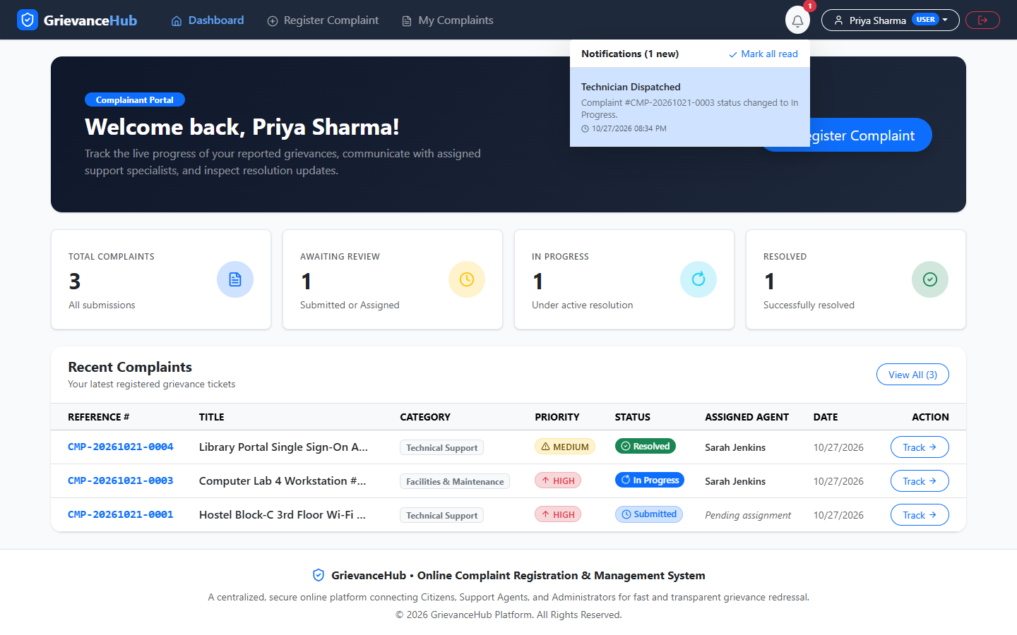  Figure 15: Notifications  In-app notification dropdown with event alerts.
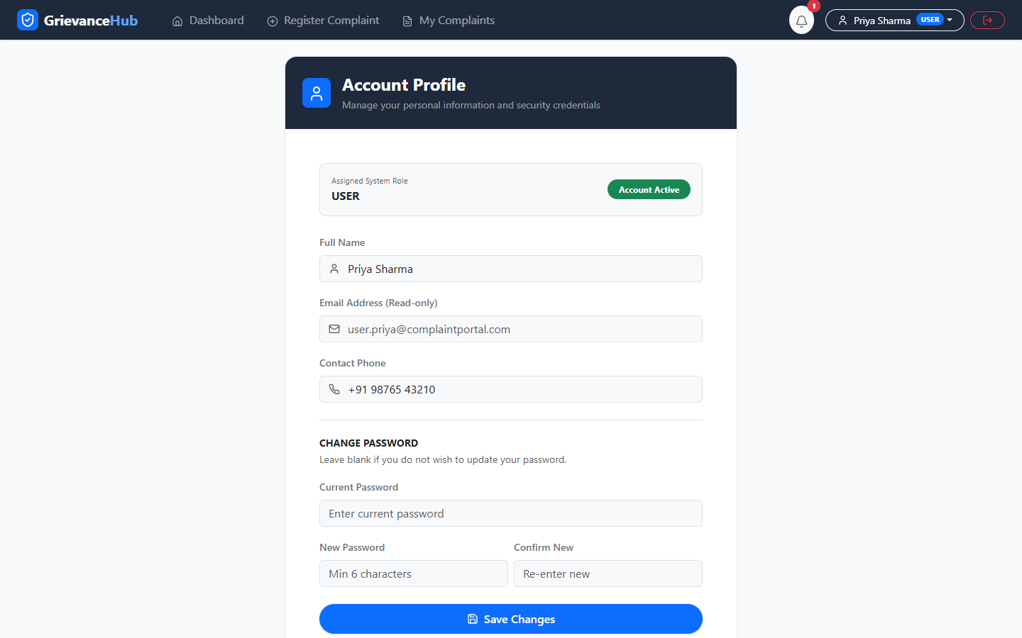  Figure 16: User Profile  Profile details and password-change controls. | 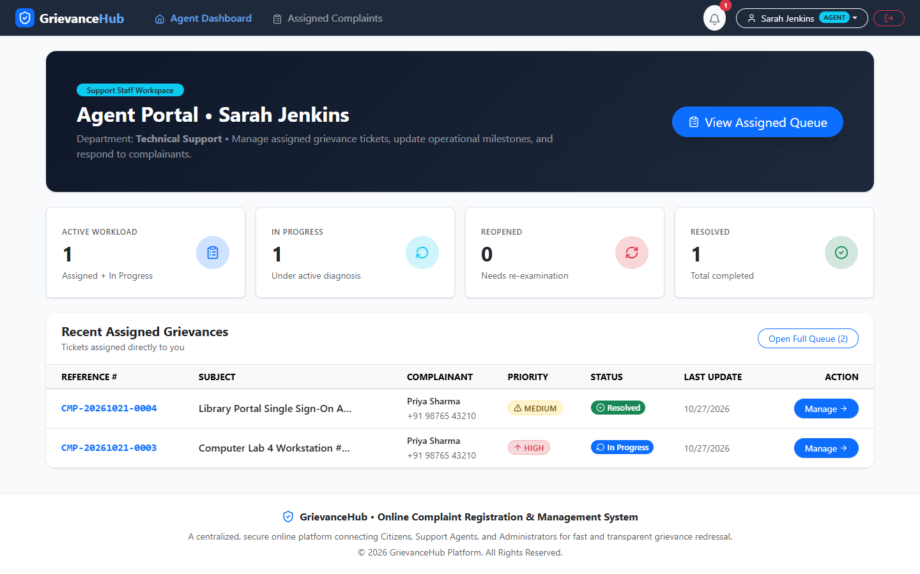  Figure 17: Agent Dashboard  Support queue overview and assigned workload counters.

AGENT WORKFLOW AND ADMINISTRATION

The agent view provides resolution controls for assigned complaints. Administrator screens provide global visibility, search/filter operations, and agent assignment tools.

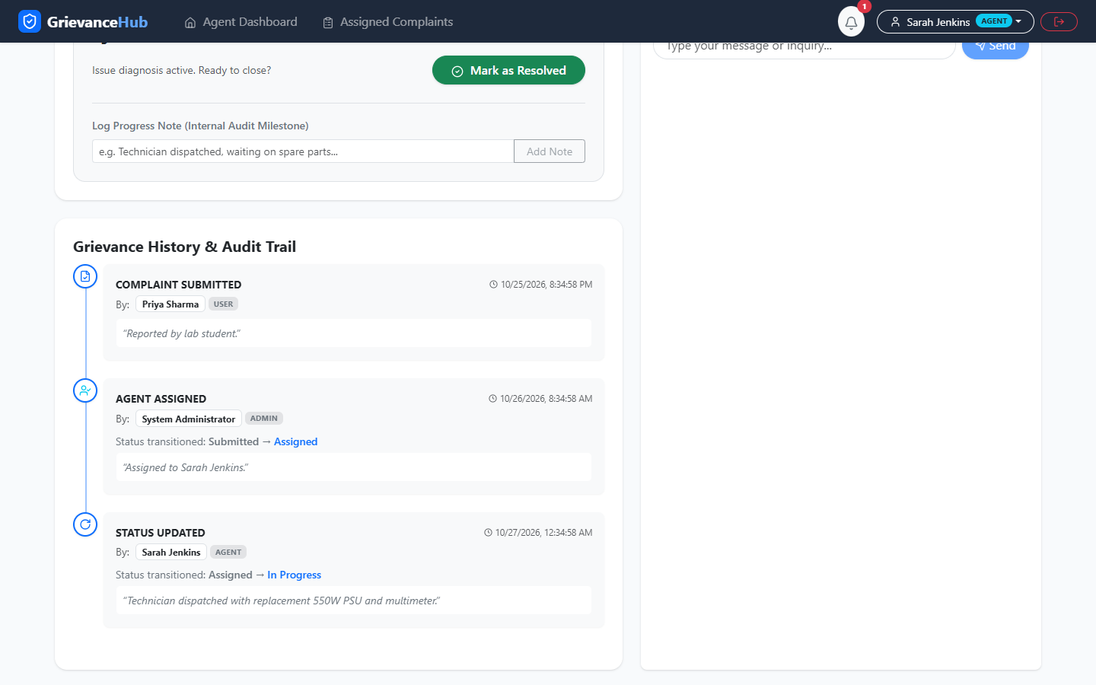  Figure 18: Agent Complaint Details  Progress note, status, resolution controls, and associated complaint context. | 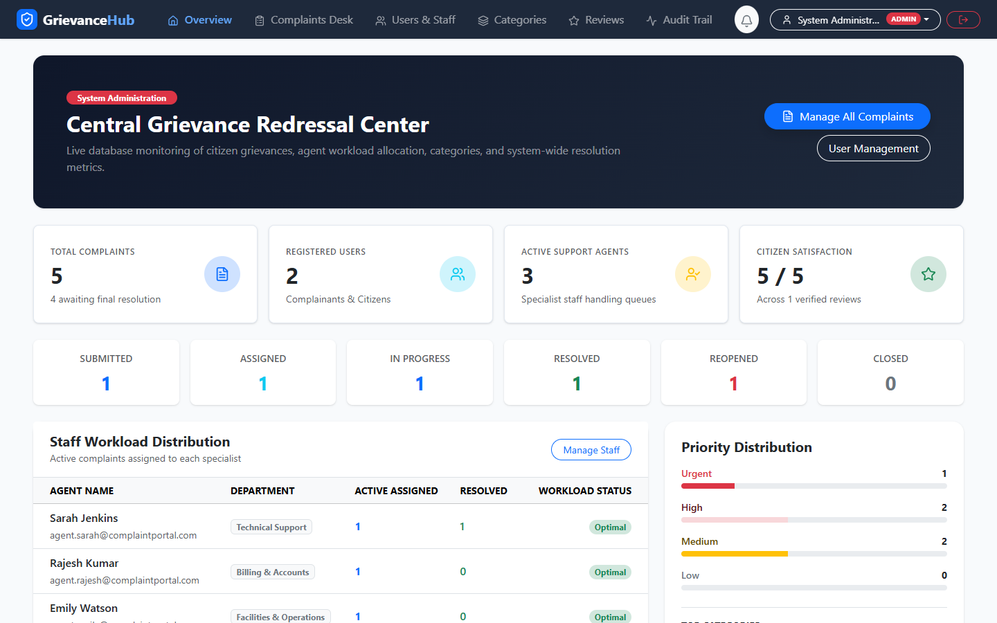  Figure 19: Administrator Dashboard  Global metrics, status distribution, category summary, and workload.
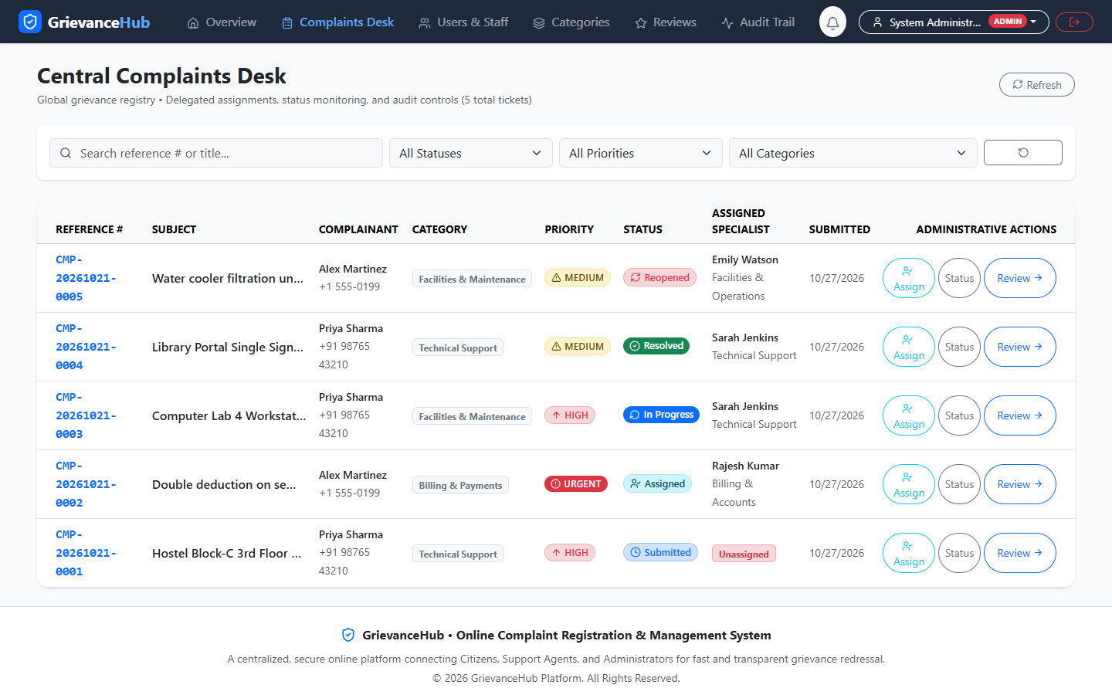  Figure 20: Administrator Complaint Register  Complaint table with search and status/category filters. | 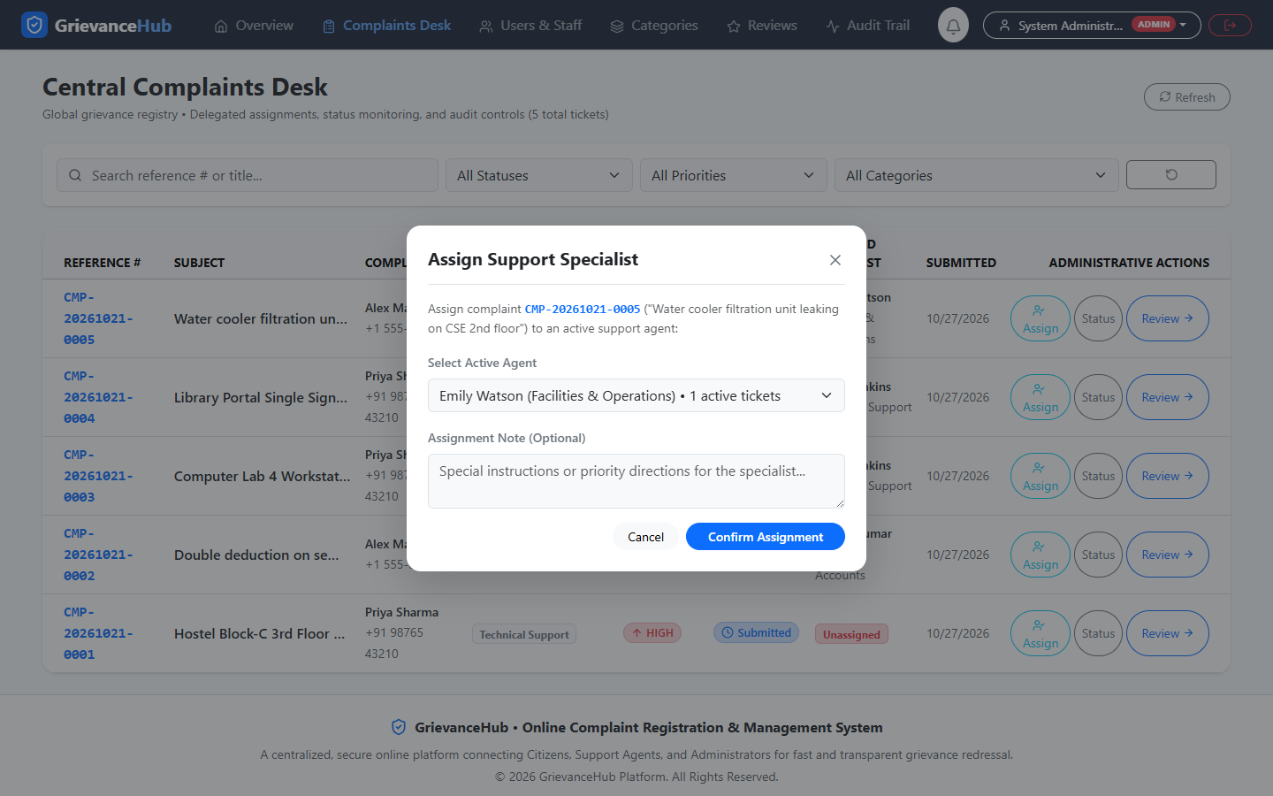  Figure 21: Complaint Assignment  Modal for selecting an eligible support agent.

MANAGEMENT AND FEEDBACK

The administration module includes user/staff management, category configuration, and review of citizen feedback. Together these views support operational governance and quality monitoring.

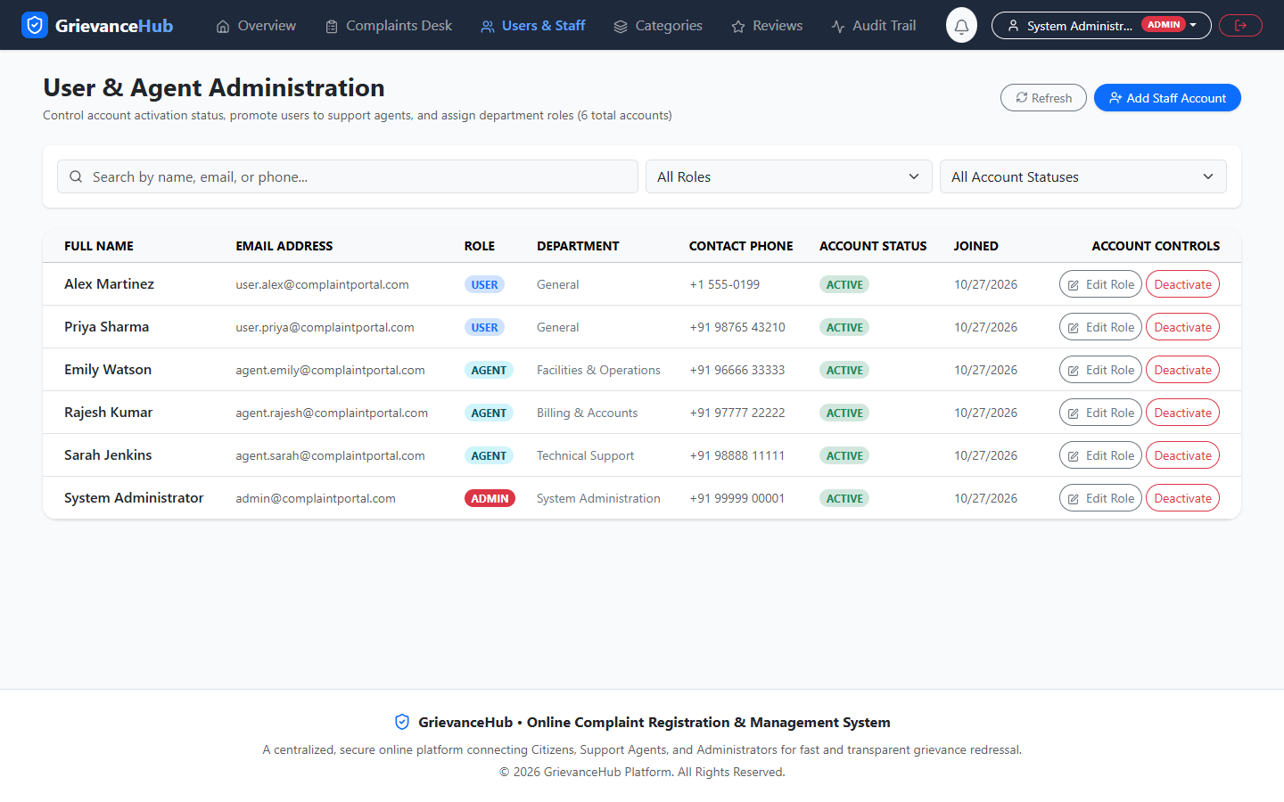  Figure 22: User and Staff Management  User directory, account roles/status, and staff provisioning. | 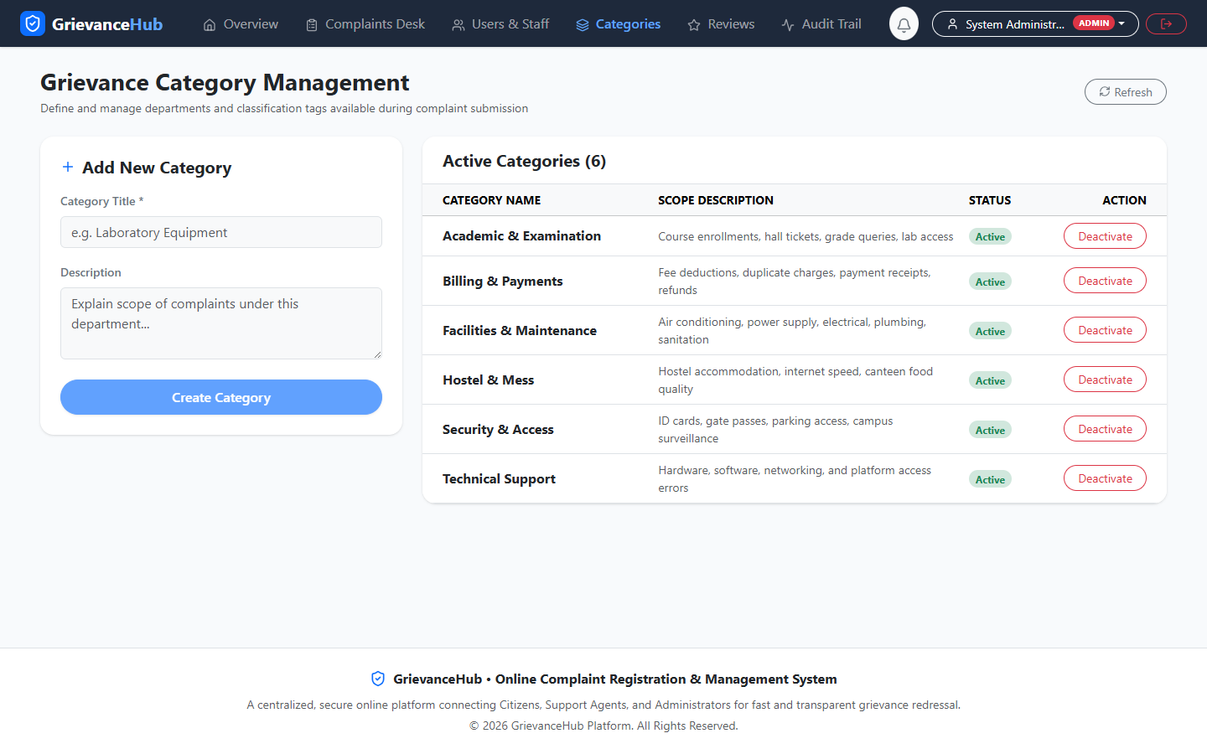  Figure 23: Category Management  Complaint category creation and active/inactive controls.
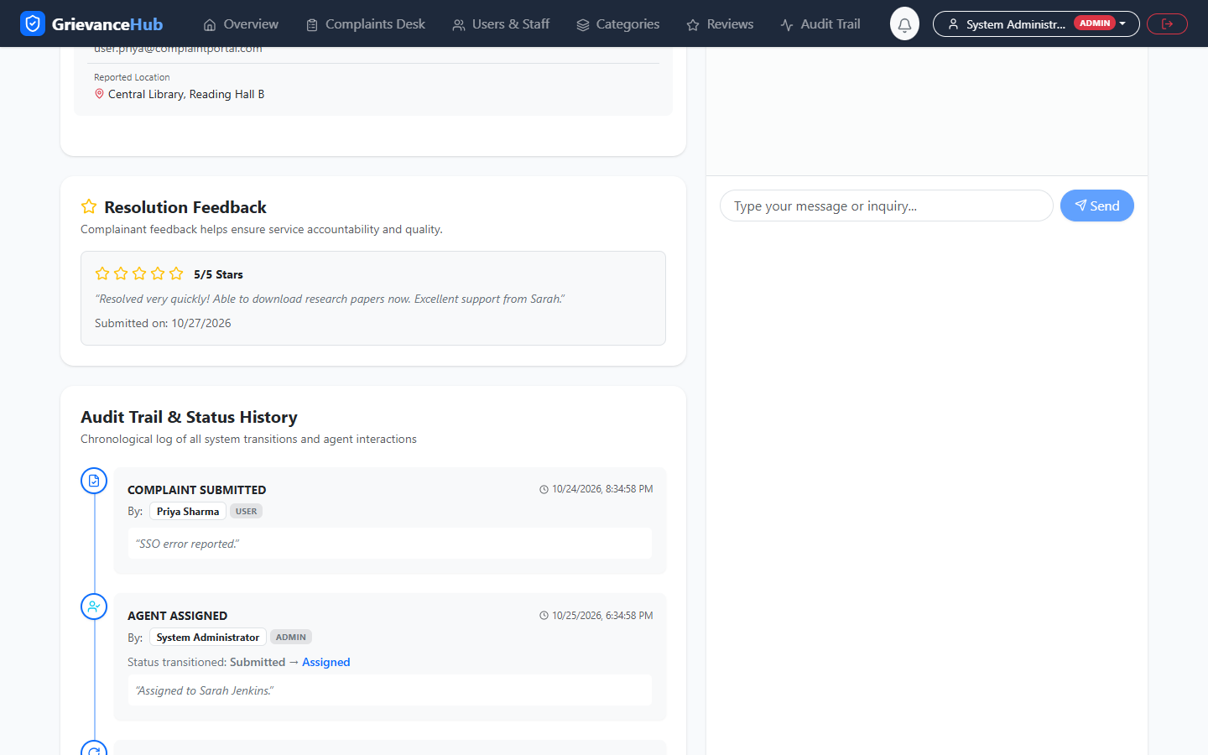  Figure 24: Complaint Feedback and Rating  Citizen rating and comments on a resolved complaint. | 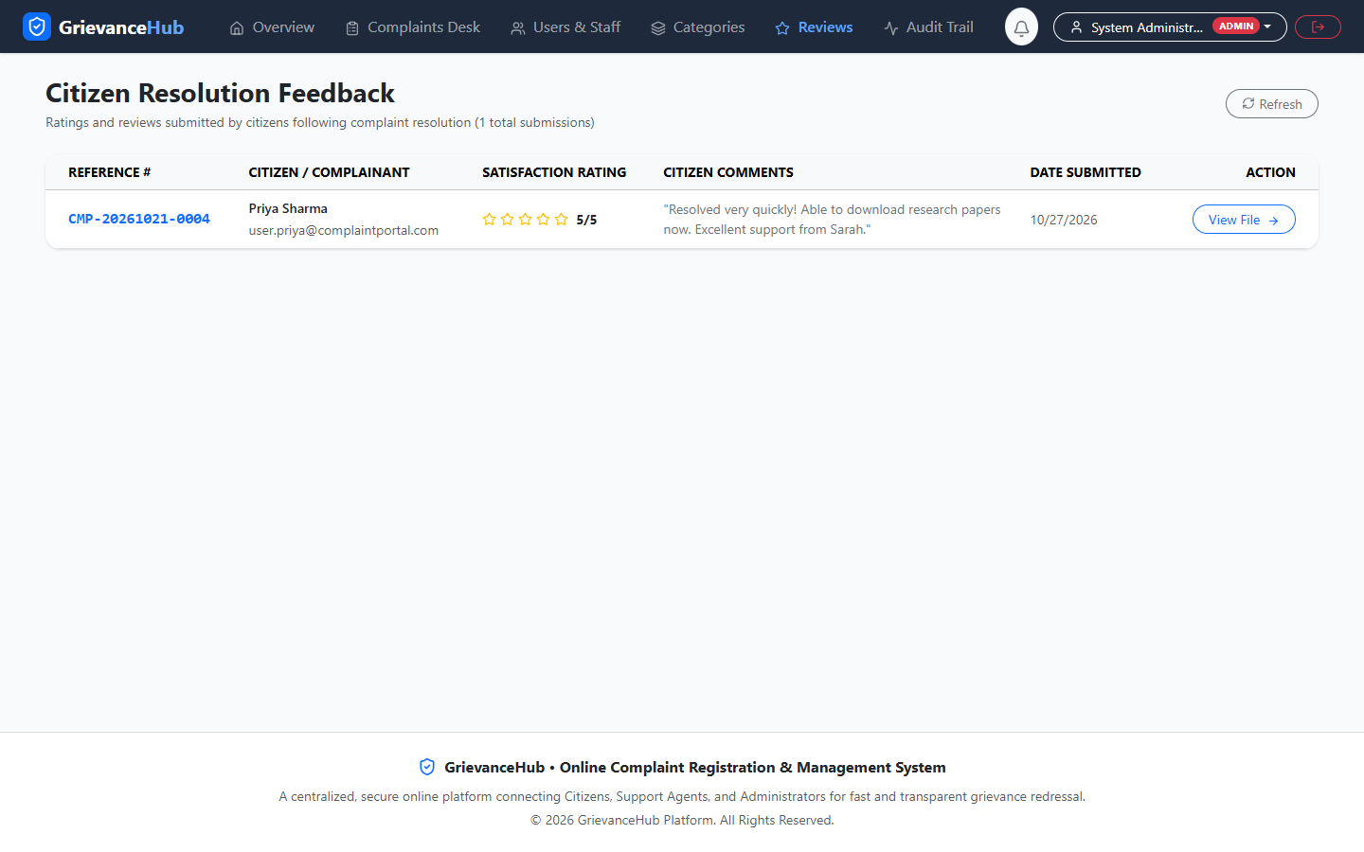  Figure 25: Administrative Feedback Report  Review table for citizen ratings, comments, and dates.

Conclusion

GrievanceHub brings complaint submission, assignment, status tracking, role-specific workflows, communication, and feedback into one centralized application. The audit and screenshot package provides supporting evidence of the reported implementation. The project can be demonstrated by following a complaint from registration through assignment, agent progress, resolution, and feedback.

